**Cloud Computing Lab Nayab Khazin**

**BSE-V B**

**2023-BSE-046**

**LAB 08**

# Task 1 — Create an AWS account and enable UAE (me- central-1)

* task1_open_signup_page.png

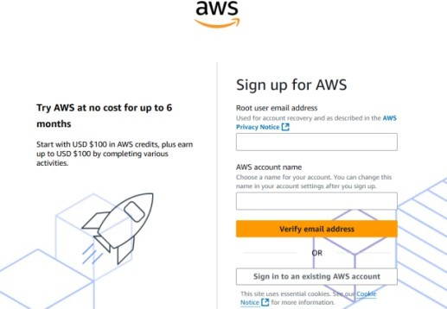

* task1_signed_up_confirmation.png

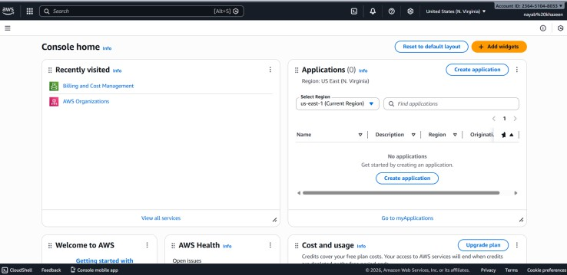

* task1_root_signed_in.png



* task1_enable_region_me-central-1.png

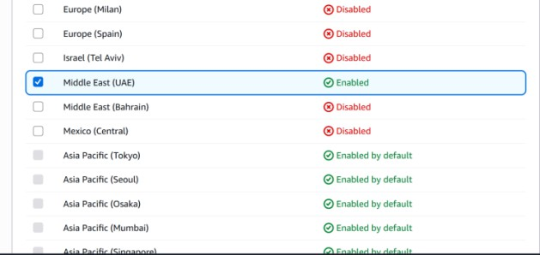

* task1_summary.png



# Task 2 — Create IAM Admin and Lab8User with console access

* task2_open_iam_console.png

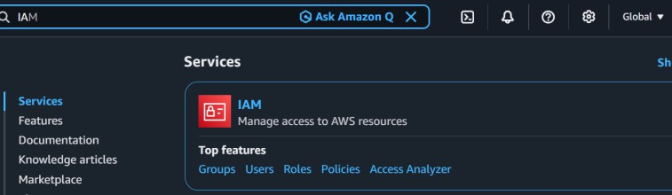

* task2_admin_create_confirmation.png

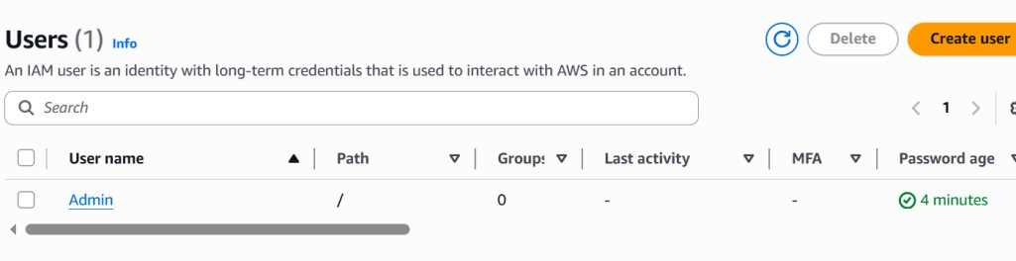

* task2_admin_csv_and_signin_url.png

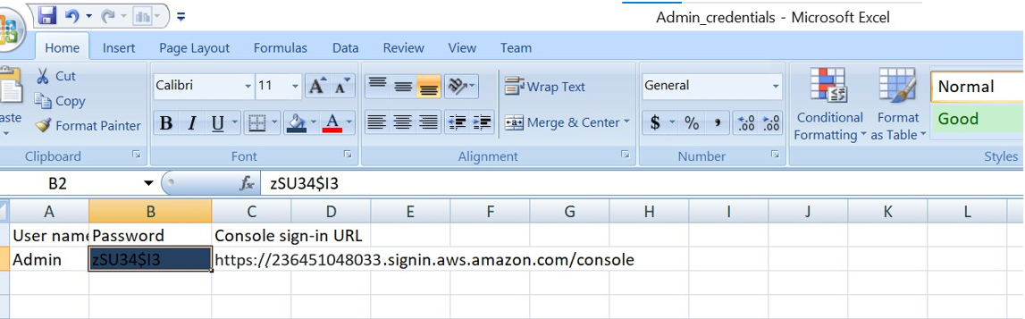

* task2_admin_console_after_login.png



* task2_create_lab8user_and_csv.png

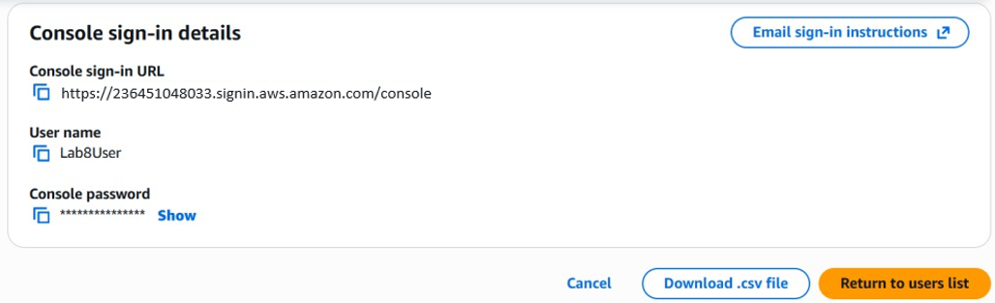

* task2_lab8user_csv_saved.png

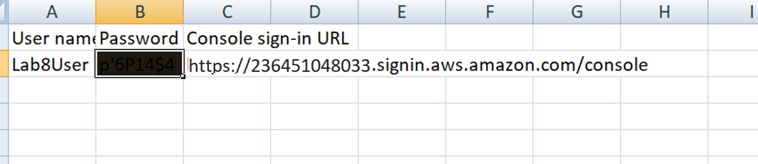

* task2_lab8user_logged_in.png



* task2_summary.png

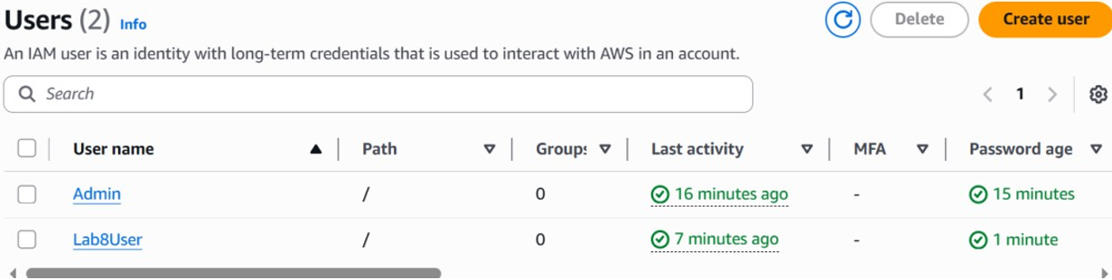

# Task 3 — Inspect VPC resources (in UAE me-central-1

* task3_open_vpc_console.png

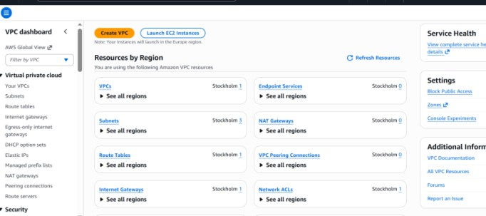

* task3_vpcs_list.png

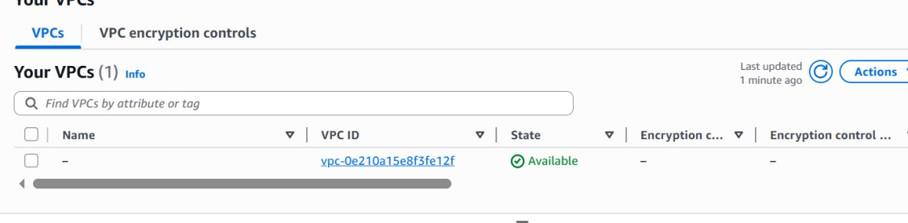

* task3_subnets_list.png

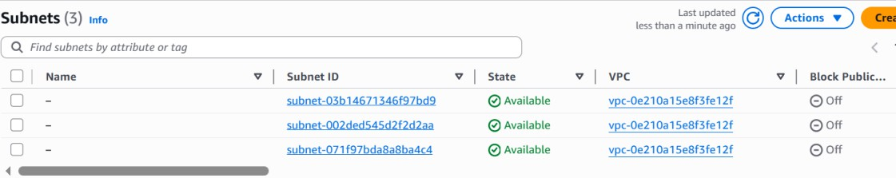

* task3_route_tables_list.png

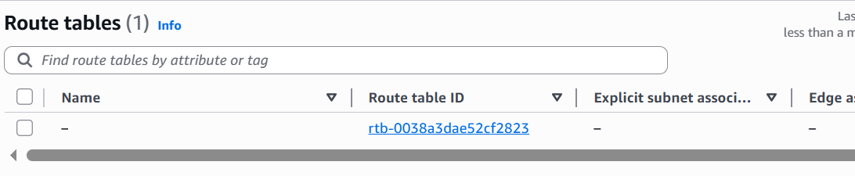

* task3_network_acls_list.png

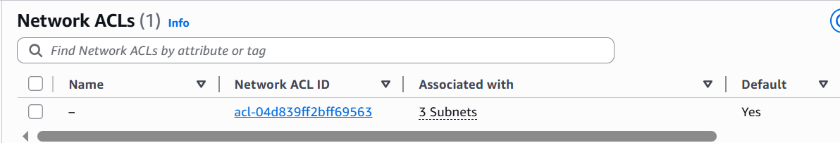

* task3_summary.png

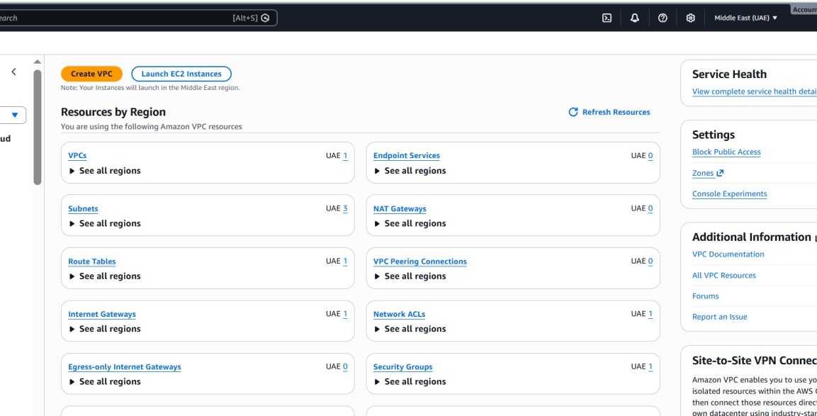

# Task 4 — Launch EC2, SSH, install Docker & Docker Compose, deploy Gitea

* ztask4_open_ec2_console.png

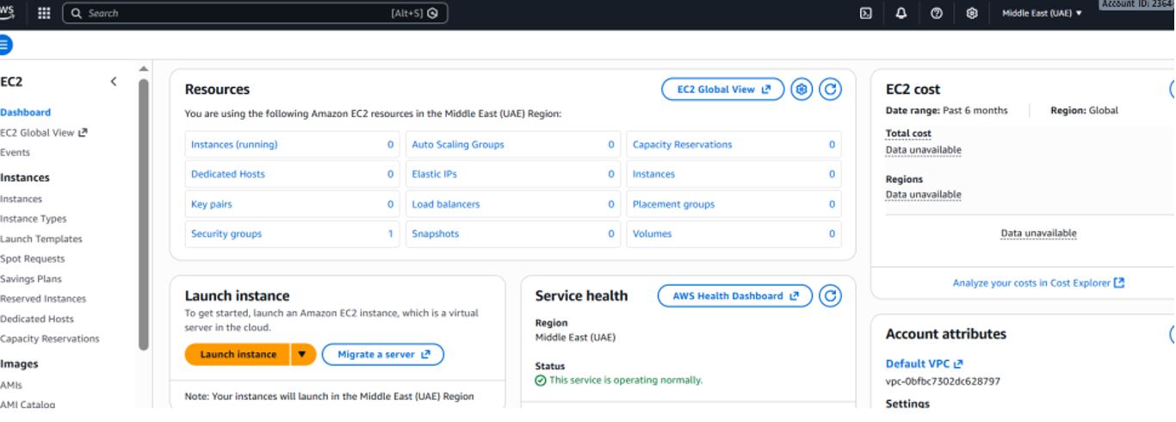

* task4_launch_instance_config.png

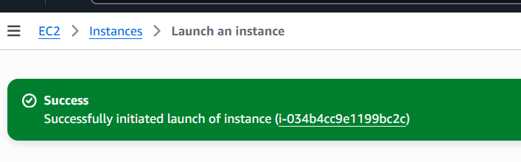

* task4_keypair_download.png

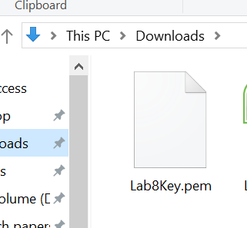

* task4_instance_running_console.png

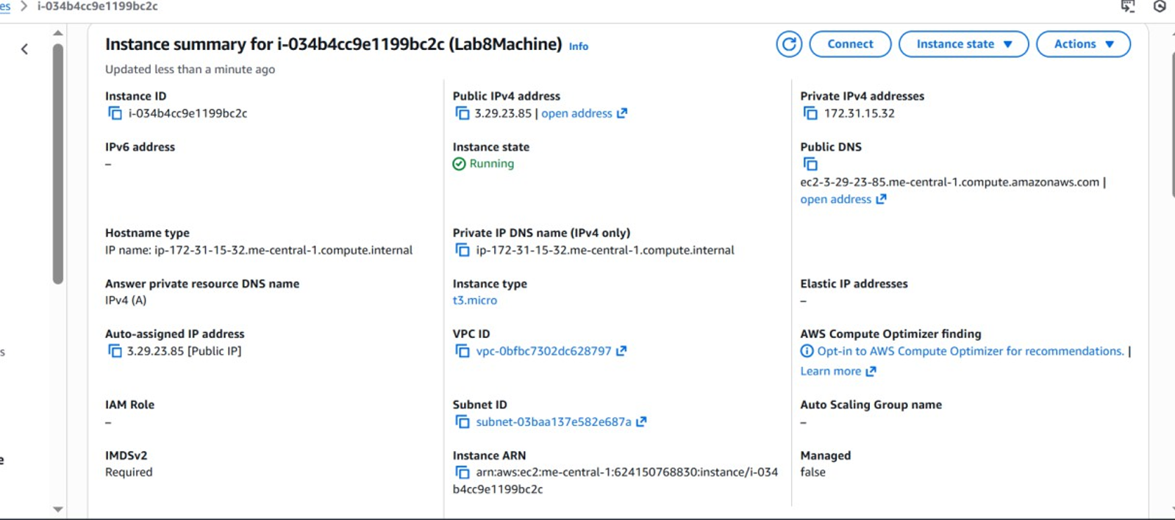

* task4_ssh_from_windows_to_ec2.png

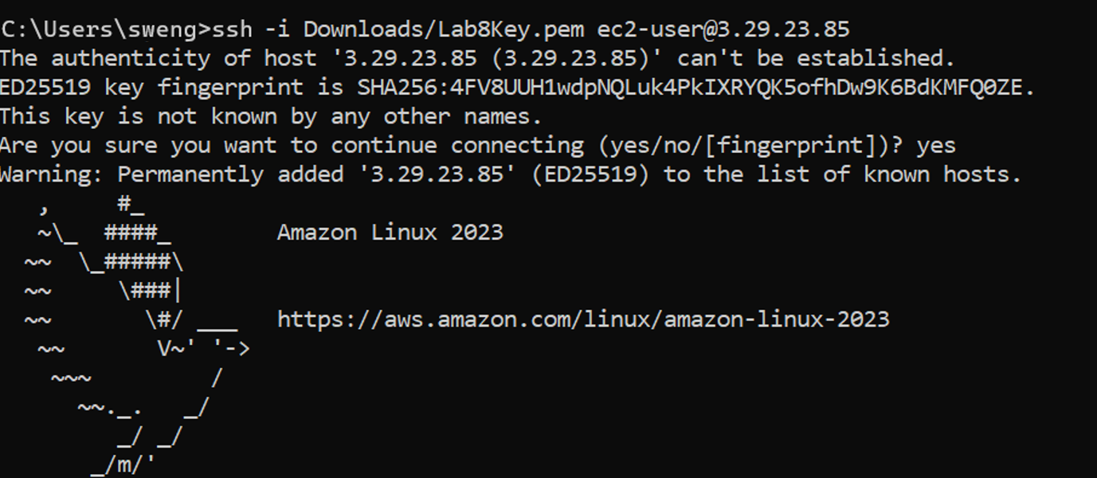

* task4_ec2_install_docker_compose_started.png

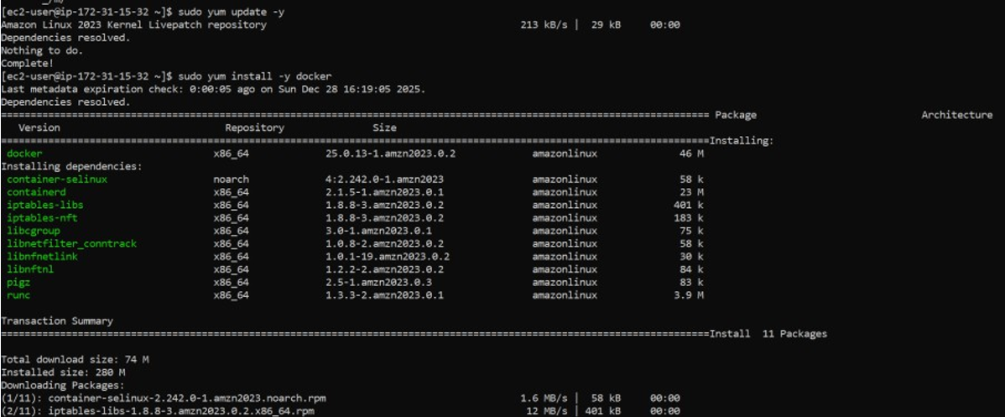

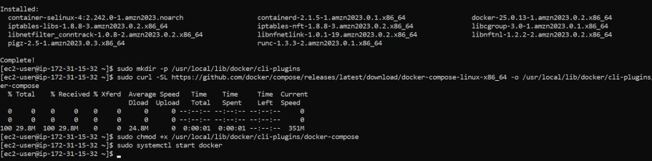

* task4_vim_compose_yaml_paste.png

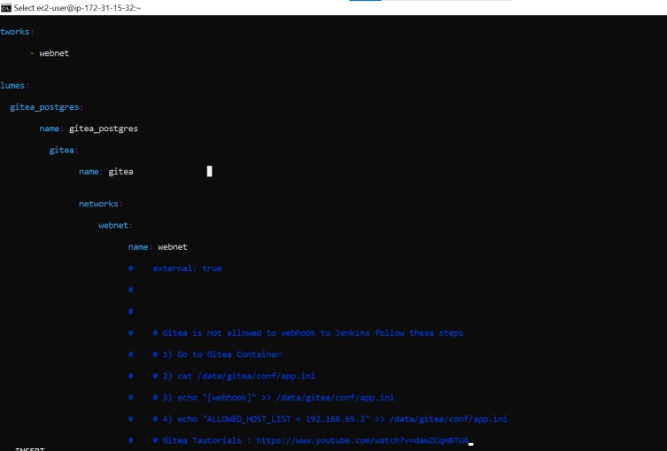

* task4_compose_yaml_saved_ls.png

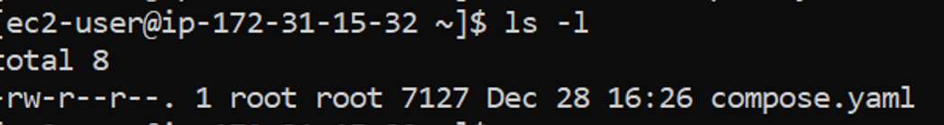

* task4_usermod_and_groups_before_after.png

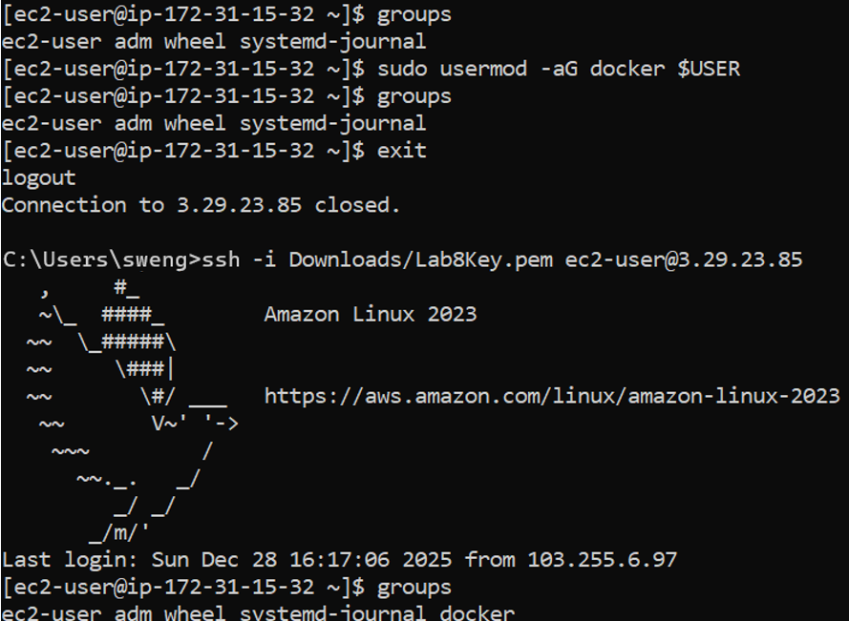

* task4_docker_compose_up.png

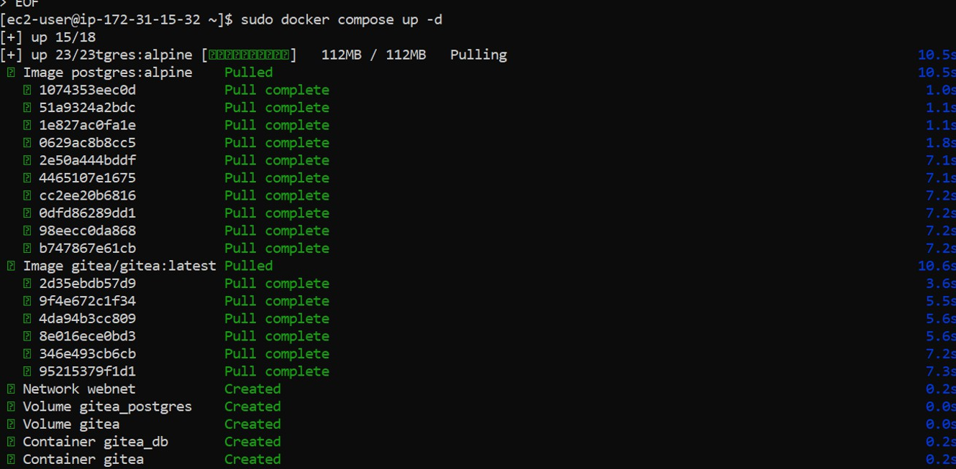

* task4_security_group_allow_3000.png

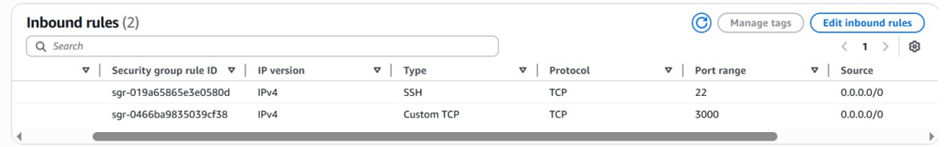

* task4_gitea_install_page.png



* task4_gitea_create_repo.png

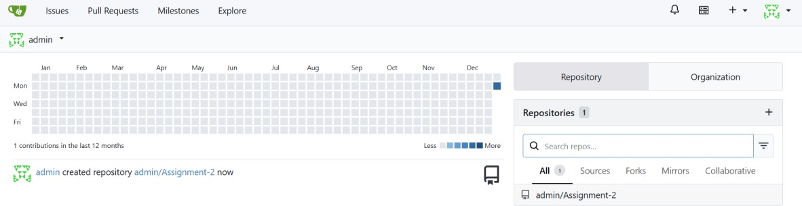

* task4_summary.png

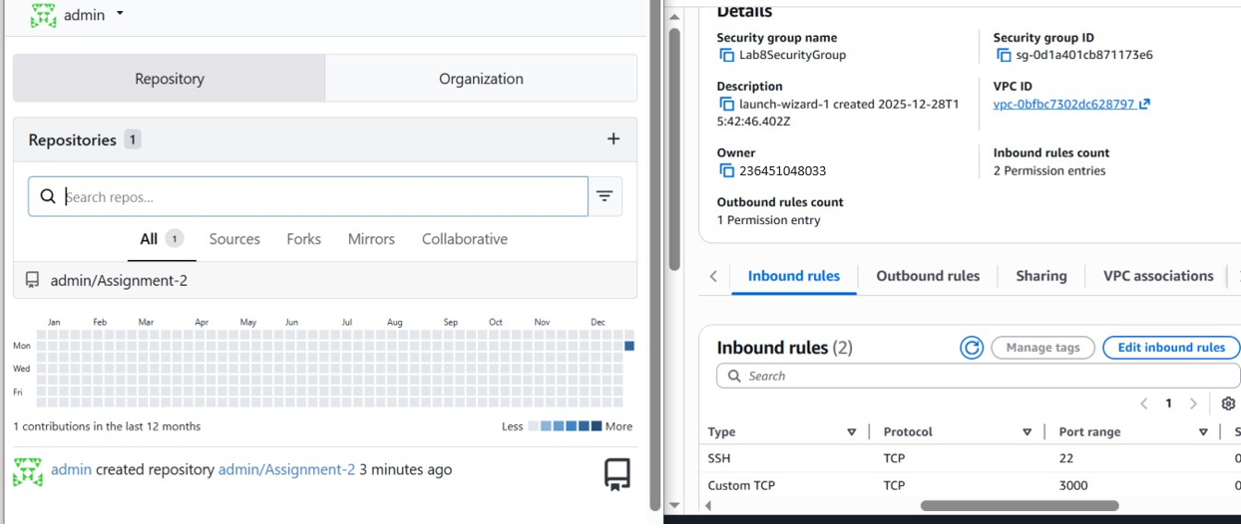

# Cleanup — Remove resources to avoid charges

* cleanup_terminate_instance.png

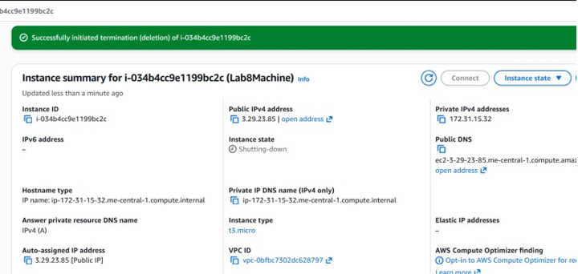

* cleanup_delete_volumes_snapshots.png

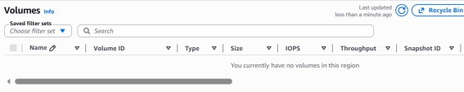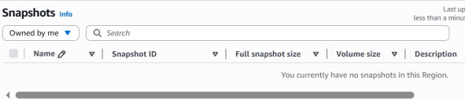

* cleanup_delete_security_group_and_keypair.png

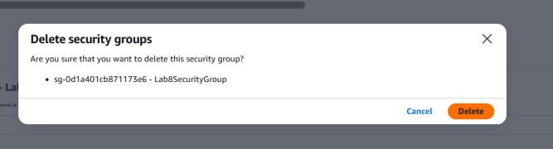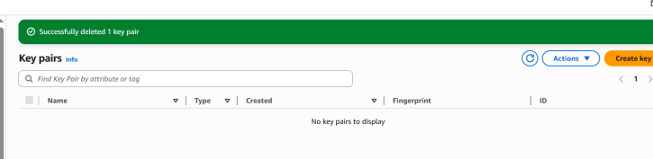

* cleanup_iam_users_deleted.png

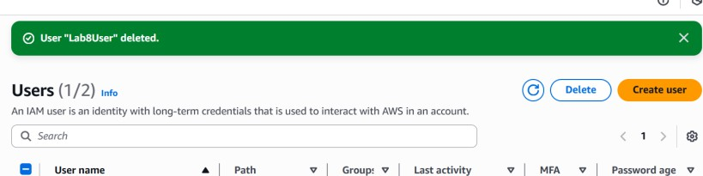

* cleanup_summary.png

